Clinical Safety Case Report
Mindbay Technologies
28th July 2025

The Clinical Safety Case Report (CSCR) summarises and reviews the clinical safety activities performed to support the implementation, deployment and use of product(s), relative to their phase of the product lifecycle.

Document Management
To be completed by the Deploying Organisation
Document filename: Clinical Safety Case Report for MindBay
Document Reference
Owner
Authors
Status
Version
Version issue date

Table of Contents
Introduction 2
Purpose 3
Scope 3
Medical Device Regulatory Assessment 3
Service Overview 3
Clinical context 4
Development lifecycle 4
Existing systems 4
Intended users 4
Clinical Risk Management System 4
Key personnel 5
Clinical safety review process 6
Clinical Risk Analysis 6
Description of patient safety consequences 7
Clinical Risk Evaluation & Control 7
Qualitative probability 8
Qualitative severity 9
Clinical Risk Management Risk Matrix 9
Risk Matrix key – Acceptability 10
Identified hazards 10
Discussion of relevant hazards 10
Hazard log 10
Hazard Workshops 11
Assessment of third party products 11
Summary Safety Statement 11
Quality Assurance and Document Approval 11
References 11

Introduction
The Clinical Safety Case Report (CSCR) summarises and reviews the clinical safety activities carried out to support the implementation, deployment and use of the MindBay product, relative to the phase of the product lifecycle. The CSCR is structured to be iterative as new functionality and changes are introduced.
The CSCR forms part of our Clinical Risk Management File and is part of a set of clinical safety documentation, which has been produced in order to meet requirements of the DCB0160 clinical risk management standard. This report contains the software definition, clinical hazards and mitigation/acceptance, and supporting evidence to provide an assurance statement on the clinical safety of the product.

Purpose
The purpose of this document is to clearly define our Clinical Risk Management processes in support of the use of the product, as well as identifying, assessing and managing clinical safety hazards that may arise from the deployment and use of the product.
Specifically, this current CSCR has been written to support the implementation of the following product(s) and the current phase of their product lifecycle(s): MindBay version 1.0 Pilot.
Subsequent and wider deployment of existing or new products will be supported by appropriate Clinical Risk Management (CRM) and an uplift to this CSCR.

Scope
This CSCR applies to MindBay (the app) v1.0. This policy applies to any local customisations or specific configurations made to MindBay v1.0. The CSCR is software product, version and development stage specific.
This scope extends to all clinical risk management linked activities undertaken during the product name, version number life cycle. All clinical functions and use cases that have potential to cause harm to patients and/or system users are incorporated.

Medical Device Regulatory Assessment
MindBay v1.0 us classified as a class I medical device

Service Overview
Mindbay Technologies builds and operates digital mental health solutions developed through collaboration between mental health professionals and AI experts.
The product, MindBay, is an interactive, chat-based conversational agent that delivers eight sessions of Cognitive Behavioural Therapy (CBT), along with between-session CBT exercises, meditation, and problem-solving tool.
MindBay uses Large Language Models (LLMs) trained on extensive datasets, enabling the generation of nuanced, context-specific responses in real time. Unlike earlier chatbots that relied on rigid rules or scripts, our tool offers a more personalised, precise and engaging experience, addressing key limitations of earlier AI-driven mental health interventions.

Clinical context
Before MindBay, GPs faced only two main first-line tools for mild-to-moderate depression or anxiety: (1) start an antidepressant - taken by 8.7 million people in England in 2023/24 despite common side-effects and patchy adherence - or (2) refer the patient to NHS Talking Therapies, where the average gap between first and second appointments exceeded three months and 1.76 million yearly referrals often received little more than review slots or self-help leaflets while they waited.
MindBay, a Class I medical device that delivers AI-supported, CBT-based conversations, is designed to supplement - not replace - these established pathways. A GP can generate an activation code through the electronic prescribing system to accompany medication or a Talking Therapies referral; clinicians can likewise issue a code at assessment so that patients on wait-lists gain immediate, guided CBT practice. Usage and symptom-change dashboards feed back to the referrer, supporting stepped-care reviews and helping teams prioritise follow-up. In this way,
MindBay functions as a scalable, cost-effective adjunct that offers timely psychological support while preserving - and never substituting for - the clinician’s judgment, pharmacotherapy, or face-to-face therapy.

Development lifecycle
The current phase of the product life cycle is the initial feasibility and pilot stage.

Existing systems
MindBay does not supersede any current IT solutions. During the feasibility and pilot phases it operates as a stand-alone product, with no interfaces to other IT systems.

Intended users
MindBay intended users are adult patients (18 years and older) with mild-to-moderate symptoms of depression and anxiety. GPs or NHS Talking Therapies will refer patients to MindBay.
For the feasibility and pilot stage, GP practices will send referral links via SMS, using an AccuRx template they create for this purpose. No additional clinical or administrative platforms are required; all patient interaction after referral is handled within the MindBay app.

Clinical Risk Management System
We have established a Clinical Risk Management System, with processes in place for both proactive and reactive clinical risk control to ensure that as many credible hazards and associated risks can be identified and anticipated as possible before they occur and any subsequent incidents that occur can be detected and resolved efficiently.
Processes are in place so that all changes or modifications are reviewed prior to a release, in line with the Clinical Safety Change Management Procedure, to ensure no changes could result in patient harm, and that any bugs that pose a potential clinical risk can be identified and dealt with accordingly.
Our CRM activities cover the following:
- Risk Analysis
- Scope Definition
- Clinical Hazard Identification
- Clinical Risk Estimation
- Risk Evaluation
- Evaluation of initial level of risk of each identified hazard using pre-defined criteria
- Risk Control
- Control Option Analysis
- Clinical Risk Benefit Analysis
- Control Measure Implementation
- Completeness Evaluation
This comprehensive and repeatable clinical risk management process is applied throughout the lifecycle of the product.

Key personnel
The list below identifies key people responsible for clinical safety within our organisation, making up the Clinical Safety team.
Clinical Safety team
Name | Role | Responsibilities
Example 1 | Trust Clinical Safety Officer | Create clinical risk management processes in the Trust  Review clinical risk management documentation  Approve clinical risk management documentation  Lead hazard identification reviews  Lead regular, episodic clinical risk management reviews
Example 2 | Project Manager | Oversee deployment of the Health IT System in the Trust  Communicate user feedback with CSO  Join hazard identification reviews  Join regular, episodic clinical risk management reviews

Clinical Safety Officer
Name | Professional qualifications | Professional Body | Competency / Skills / Experience | Clinical Safety Training
Trust CSO

All documents created as part of the Clinical Safety Management System are maintained, version controlled and managed by the Clinical Safety Team and authorised by the Clinical Safety Officer. Documents are stored in the Clinical Risk Management File, which has appropriate access control measures in place.

Clinical safety review process
Clinical Safety change management procedure
We maintain a Clinical Safety Change Management Procedure. This ensures any product modifications or updates, or any new bugs that have been logged, will be assessed for any potential clinical risks that may be introduced, prior to release onto a live environment. These will be reviewed by the Clinical Safety team to ensure any change is either not released, or has an acceptable level of risk. The hazard log will be updated accordingly.
Clinical Safety incident management procedure
We maintain a Clinical Safety Incident Management Procedure, in which incidents that might impact patient safety are reported and managed appropriately, with requirement for CSO assessment if the severity dictates.

Clinical Risk Analysis
As is the nature of clinical software, hazards are always likely to be present. It is important to reduce the likelihood of these hazards occurring, as well as the potential impact of each hazard.
Clinical risk analysis involves identification of hazards, description of patient safety consequences, explanation of hazard causes and effects, identification of existing mitigating controls and estimation of clinical risk.
Hazard Identification (HAZID) is performed using the Structured What If Technique (SWIFT) and/or Functional Failure Analysis (FFA). At each step of the process; a checklist of possible ‘things that could go wrong’ are documented following structured discussions, taking into account technical, human and organisational factors within processes and procedures that may affect safety and the potential safety consequences; the functionality is questioned in terms of what could happen, what a user could do, what a user will know and what the system does. This hazard assessment considers information security, operational security, information governance, privacy and confidentiality and human behaviour and usability / GUI hazards and threats that could potentially have an impact on patient safety.
Hazards are defined using the cause > effect > hazard > harm framework:
- Cause: Consider events or actions that occur in the care-pathway that causes a deviation in the intended care process. Have all the potential scenarios that could cause a hazard or threat to occur been considered?
- Effect: The deviation that occurs in the care-pathway as a result of the cause
- Hazard: The condition that is created in the care-pathway as a result of the effect that has the potential to cause harm
- Harm: The realisation of harm to the patient
Details of any completed hazard assessment workshops can be found in the Appendix.

Description of patient safety consequences
What are the patient safety consequences of the product? It can be helpful to divide this into direct and indirect consequences). Example indirect consequences may be delay to patient care, delay in receiving clinical/administrative support, wasted clinical resources

Clinical Risk Evaluation & Control
Each identified hazard is evaluated for the initial level of risk using pre-defined criteria.
The risk matrix grade is based on:
- Likelihood: How likely each identified consequence is to actually occur
- Consequence: For each combination of cause and hazard, were the hazard to be realised, what potential outcomes for patient safety are there
- Severity: The seriousness of each consequence is considered, in terms of individual patient harm
For each risk we consider the following as part of our evaluation:
- Actions: Actions taken or proposed to prevent or reduce the safety risk where possible.
- Acceptability: What top management consider to be acceptable risks and why
- Review: How often each residual risk/hazard is reassessed and actions evaluated

Qualitative probability
The defined levels for the probability of harm are as follows:
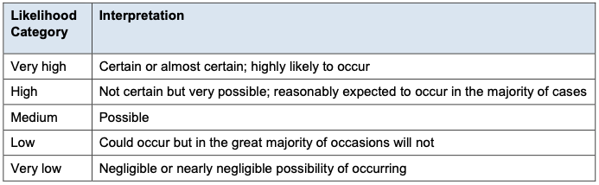

Qualitative severity
The defined levels for the severity of harm are as follows:
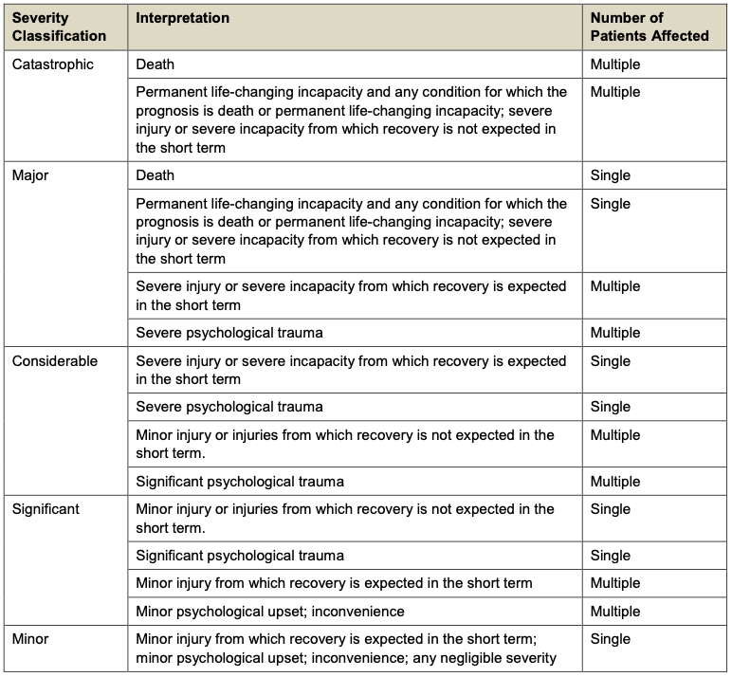

Clinical Risk Management Risk Matrix
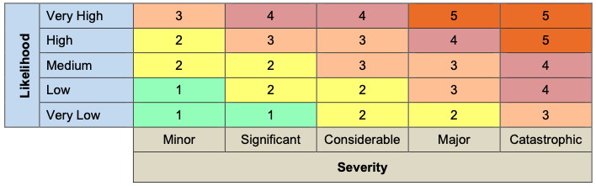

Risk Matrix key – Acceptability
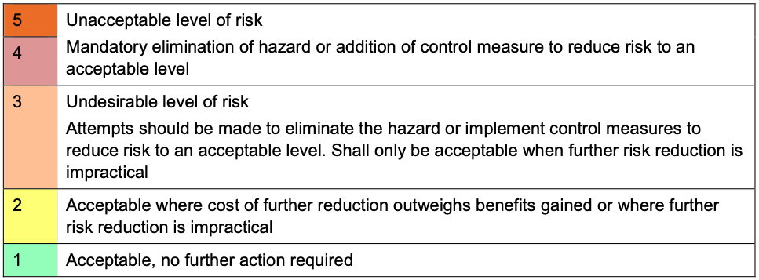
The subsequent approach for review and re-evaluation of these hazards will be the responsibility of the clinical safety team which will include:
- Consider the existing safeguards which would prevent or reduce the safety risk.
- Given those safeguards, grade each risk using the combination of consequence severity and likelihood.
- Identify recommendations for mitigation or controlling hazards to reduce risk.
- Given those mitigations, re-grade each risk using the risk matrix.

Identified hazards
Summary of identified hazards for (product name, version number)
To be completed by the deploying organisation

Risk-benefit analysis and justification (if applicable)
Summarise any justifications and risk benefit analysis if applicable, or delete this section if not

Discussion of relevant hazards
Discuss the most relevant hazards (such as those with an initial risk score of 3 or more, or those with a residual risk score of 2 or more), including the relevant controls that have been implemented

Hazard log
The full Hazard Log can be found separately. It is provided in the NHS Digital format, and provides evidence to support compliance with DCB0160

Hazard Workshops
Include details of completed hazard workshops here (such as dates and attendees)

Assessment of third party products
Include a list of any third party products and consider their use and potential clinical safety impact

Summary Safety Statement
Summary safety statement to be written by the named CSO after analysis of identified hazards and risks. This must include the safety position of the Health IT System in the context of the intended deployment.

Quality Assurance and Document Approval
This CSCR has been developed, reviewed, and approved in accordance with the arrangement described within the Clinical Risk Management Plan.

References
Reference 1
DCB0129: Clinical Risk Management: its Application in the Manufacture of Health IT Systems, NHS Digital, NHS England
Reference 2
DCB0160 : Clinical Risk Management: its Application in the Deployment and Use of Health IT Systems, NHS Digital, NHS England
Reference 3
Guidance : Medical device stand-alone software including apps (including IVDMDs), MHRA (Medicines & Healthcare products Regulatory Agency)

